November 22, 2019

President’s Message

Halloween parade and book fair are complete, and winter is moving in fast. The second marking period has started, and the kids are all ready... for winter break. But don't fret because December means a community favorite, World Culture Night!!! Volunteer to show off your heritage with a performance, a display, or food offering. As we approach the holiday season, remember to register your Amazon Smile account with Travilah ES as the 501c3 to which they should donate.

But first, next week we break for Thanksgiving. A time for family and friends to gather and reflect upon things we are grateful to have. When that time comes, remember to spare a thought for our wonderful school and the teachers that make our kids days brighter.

Happy Thanksgiving!!

Also coming soon is World Culture Night. For more information, or to register to participate, see attached flyer!

Calendar of Events

November
27 | 1:20 pm | Early Dismissal
28 - 29 | - | No School / Thanksgiving Break

December
3 | 7:00 pm – 8:00 pm | PTA Meeting
10 | 6:00 pm – 8:00 pm | Winter Concert
12 | 6:00 pm – 8:00 pm | World Culture Night Rehearsal
13 | 6:00 pm – 8:00 pm | World Culture Night
23 - 1 | - | No School / Winter Break


Read-a-Thon
Committee Chairs: Debbie Rothbard and Robyn Bender
The Read a Thon ended last week, and all the minutes have been counted! A huge thank you to everyone who participated and made this such a fun and exciting event for our whole school!

Congratulations to all our readers on an amazing job! As a school, we read a total of 35,055 minutes! WOW! You all should be so proud of the fantastic job you did reading!

Here are the winners for each grade for most minutes read:

Kindergarten- Joseph He (Ms. Gilbert's class) 552 minutes read
1st Grade- Logan Wolff-Cohen (Mrs. Foley's class) 886 minutes read
2nd Grade- Tristan Davis-Astrada (Mrs. Jarczynski's class) 1,040 minutes read
3rd Grade- Karim Sangare (Mrs. Bowman's class) 1, 950 minutes read
4th Grade- Zahra Ali (Mrs. Singal's class) 1,390 minutes read
5th Grade- Shruthi Venkatesh (Ms. White's class) 900 minutes read

The student that had the most minutes read for the whole school was Karim Sangare in Mrs. Bowman’s class with a total of 1, 950 minutes read. Congratulations Karim!

Thank you again to all who participated and don't forget to KEEP READING!!

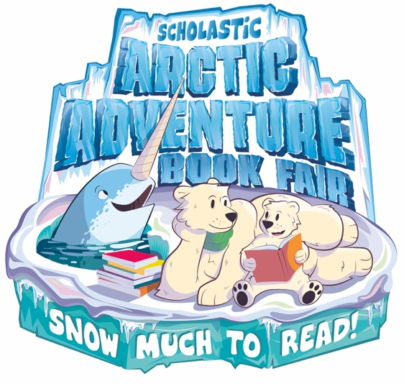
Book Fair
Committee Chairs: Debbie Rothbard and Robyn Bender
The 2019 Arctic Adventure Book Fair was a huge success! It was wonderful to see all the students and teachers come into the media center every day so excited to shop for new titles to take home and read! Students also really enjoyed many fun guessing games and raffle prizes during the fair as well! We had a great turn out for Family Fun Night where families enjoyed shopping the fair! Pizza and s'mores were sold in the AP room and everyone really enjoyed bringing blankets to sit around our "campfire" to listen to some fantastic guest readers, including Dr. Wade! The Grand Event and Pastries for Parents were also well attended. Thanks to your tremendous support, we sold over $14,000 dollars worth of books at the fair this year!

The Book Fair would not be possible without the help of some amazing parent volunteers! Elena Christopher and Rebecca Ali did an incredible job with the decorations outside the media center, thank you both so much for your time and creativity in creating such a magical display! A big Thank You to Yoonie Min for organizing and setting up the teacher preview breakfast, which was delicious as always! Thank you to Nicole Lockhart for organizing bakers to donate treats for Pastries for Parents! Finally, a HUGE thank you to all the parent volunteers that came in to work the book fair everyday, helped out during Family Night and donated delicious breakfast treats for the Pastries for Parents event! We could not have done any of this without your help and support so THANK YOU Jennifer Lucchese, Aiping Zhang, Monali Shenolikar, Nirupama Desai, Anahita Yousefi, Becky Zief, Katie Basilio, Karina Wu, Hao Zhang, Caroline Cho, Crystal Kwon, Laura Fallot, Allison Brenner, Meskerem Gurmu, Amanda Nesher, Monica Delgado, Elvira Godynskaya, Christiane Grune, Natalie Silber, Kelli Lewis, Jodi Rosenman, Ritu Kanotra, Jennifer Meyers, Nicole Lockhart, Paloma Richard, Fay, Horng, Tram Lam and Josiah Cushing.

World Culture Night

World Culture Night is coming Dec 13th!!!

World Culture Night is always a fabulous Travilah tradition, representing a multitude of countries from around the world! Parents and students set up booths representing their culture, hand out tasty samples of traditional food, come in traditional dress, and perform on stage. For more information or to register to participate fill out the attached form.


Thanks!

The board would like to thank:

- Robyn Bender and Debbie Rothbard for organizing and running the book fair.

- Nicole Lockhart, Shawn Wang, Tram Lam, Becky Zief, Alping Zhang, Mohanambika Malledi, Katie Basilio, Andrea Goren, Robyn Bender, Caroline Cho, Hao Zhang, Yoonie Min, Rebecca Ali, Vinny Singh for volunteering to help with the Teacher Thanksgiving Luncheon.

- Hao Zhang and Ting Wang for all their hard work on with membership and the directory.

Grocery Receipts

Did you know there are several easy ways to support our school simply by doing what you already do?

All it takes is a few minutes to associate Travilah Elementary School to your accounts with these retailers and viola! Travilah Elementary School receives a contribution every time you make a future purchase. It’s THAT easy!

Here is the What, Where and How.

Amazon Smiles    When you shop at www.smile.amazon.com, you’ll find the exact same low prices, vast selection and convenient shopping experience as Amazon.com, with the added bonus that Amazon will donate a portion of the purchase price to Travilah ES PTA to help support your child’s school activities. | What to do:  - Sign in to your Amazon account at www.smile.amazon.com  - Search and select Travilah Elementary School PTA as your charitable organization  - Next time you shop, be sure to go to www.smile.amazon.com and NOT www.amazon.com  Bookmark www.smile.amazon.com to help remember to start your shopping there. Remember there is absolutely no cost to you!
Harris Teeter -  Together In Education    Harris Teeter’s Together In Education program gives Travilah ES a chance to earn funds when you shop Harris Teeter brands. A percentage of your purchase is donated to the school that your VIC card is linked to.  There are NO LIMITS to how much our school can earn! | What to do:  Option 1:  - Next time you shop at Harris Teeter, simply give the cashier your VIC card and the Travilah ES Together In Education number 7373 during checkout.  - The cashier can link your VIC card to the Travilah ES Together In Education number.  Option 2:  - Register your Harris Teeter VIC card online at https://www.harristeeter.com/user/#/app/user/login or Sign in to your Harris Teeter account if you are already registered.  - Click on the Together In Education logo and associate your VIC card to the Travilah ES Together In Education number 7373

World Culture Night Registration Form

12/12 6-8p Rehearsal; 12/13 6-8:30p World Culture Night

- Display table (no rehearsal needed)
Country:
Contact name/ Email:

- Performance (Encourage group performance: you need have at least two participants, please keep each performance less than 3 minutes. Rehearsal is necessary.)
Name of the performance:

Type of the performance (e.g. Dance, martial art etc):

Briefly describe the performance:

Performance time:

Name and grade of each participants:

Please submit the music you are going to use, no later than Dec 6th in MP3 format
Email back to: zhenyuanzy@hotmail.com

